Class: 1A Teacher: Adriane Cioppa Date:__October 4, 2016

Lesson:_Questions with answers in simple present and simple past/ contractions

Skill Objective #1 (Students will be able to…)
SWBAT listen, understand, and answer questions on a familiar topic with vocabulary support.
Frameworks: Standard S1.2b
Content Objective #1 (Students will know that…)
Answer questions using simple present and simple past tense verbs.

Activities (20 min)
1a. Conversation in the classroom. Inside-outside circle
Before you start the activity go over the vocabulary that students may not know and need to know for the activity.
VOCABULARY
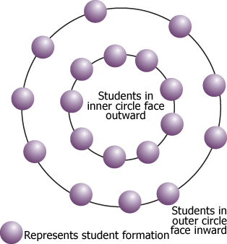
Childhood - a time when you are young
Teenager – someone between the ages of 13 to 19
Middle-age- someone neither young or old – usually between 40 and 50
Toddler – a young child – between ages 1 and 3
Retirement- the period after you finish your working life – usually after 65 y
Pensioner – someone who has finished their work life and get a pension from their former work
Pension – a regular payment for a person after retirement
Agree – you think it is right Disagree – you think it is NOT right
Advice – an opinion of how to act in the future, a recommendation, suggestion

- After you write on the board the vocabulary for the activity, write the questions on the board and have students copy and answer them in their notebook. About (20 minutes) leave the vocabulary words on the board so students can refer to them as they answer the questions. You may add any other word that students don’t know.
Questions:
- - What’s the best age to be? Why?
- – How old were you when you left home? Were you afraid? Why?
- – What do you think is the best age to have children? Why?
- – What’s the retirement age in your country? Do you think it is a good age to retire? Why?
- - Would you like to live until you were 1000 (one thousand) years? Why?
- – In your country, how old must you be to smoke, drink, drive, and get married? Do you agree with it? Why?
- – What advice you would give to someone half your age? Why?
- – Have you ever lied about your age? Why?
- – Do you think age difference is important in a relationship? Why?
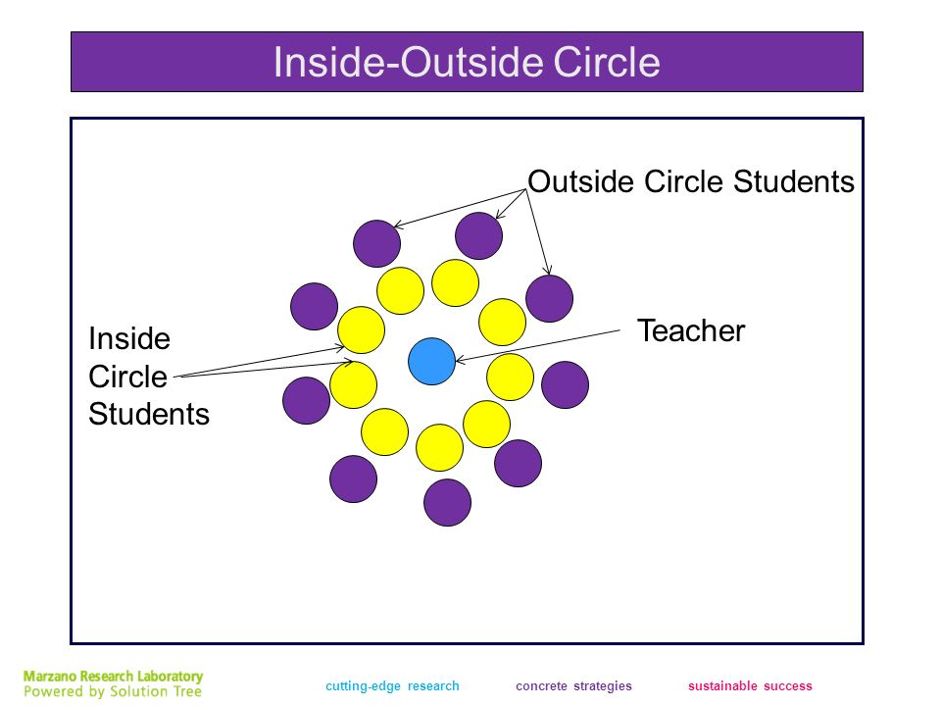 (30 min)

- Organize the classroom in a way where you have space in the middle (you might want to put the tables and chairs against the wall. have students form an inside and outside circle (see picture).
- Distribute the questions to the students in the inside circle to ask the outside circle students
- Give one minute for each answer. Rotate the circle.
- Rotate the outside circle to the right. Inner circle does not move. They ask question to the next person from the outside circle, and so on.
- You should have a matching number of students in inner and outside circle. If there is one more student you should also participate to make a pair with the extra student. You ask the questions.
- After you finish rotating (all students on the outside circle should have answered all questions) switch the questions. The outside circle people get the questions and the inside circle answer them. The inner circle rotates now. (it should take about 30 minutes)

Materials Strips with questions

Assessment #1

Students’ ability to understand, access the vocabulary, and answer the questions.

Wrap Up Reflection
Have students write one or two statements questions they learned to answer. Each student should read them out loud. (15 min)

Skill Objective #2 (Students will be able to…)
Identify and use pronouns to replace nouns.
Frameworks:
Standard L2.2f
Content Objective #2 (Students will know that…)
Identify and use in sentences simple present tense with or without contractions.

Frameworks:
Standard L2.2f
Activities

1a. Explain the pronouns replace nouns. Ex: Marie = she; Carlos = he; John and Max = they; cat = it; John, Marie and I = we, and so on. (15 min)

Give a few examples:
My pencil is at home = It is at home
Mary is sick today = She is sick today
Mary, Marcos and I are at school = We are at school.

Have students give a few oral examples. (15 minutes)

Review contractions - write on the board (10 Min)
I am – I’m
You are – you’re
He is – he’s
She is – she’s
It is – it’s
We are – we’re
They are – they’re
Is not – isn’t
Are not – aren’t

Go over and explain any questions student might have.

Students do all activities on page 3 – (about 20 minutes) all answers should be corrected on the board so students can have the spelling visual of the answers.

Students do also activities on pages 7, 8, 9, and 10. Correct everything always asking student to answer the questions

Materials English In Action Book

Assessment #2

Have students look at the pictures on page 6 and have them write five sentences that are true about the pictures and five sentences that are false about the pictures using pronouns and the verb to Be with or without contractions. (20 min)

Wrap Up Reflection Students read aloud their sentences. (15 min)

