A

The Surprising Effects of Retrieving Information from Memory
“When we think about learning, we typically focus on getting information into students’ heads,” say Pooja Agarwal, Henry Roediger, Mark McDaniel, and Kathleen McDermott. “What if, instead, we focus on getting information out of students’ heads?”
The central message of this paper is that retrieval should be used not as an assessment tool (classroom questions, quizzes, and tests) but as an everyday learning strategy. Research has shown that retrieval is much better for cementing understanding in long-term memory than commonly used strategies like re-reading, highlighting, underlining, note-taking, reading review sheets, watching a video, and listening to a lecture. These strategies may produce short-term gains when cramming for a test, but memory researchers have found that they don’t produce long-term retention. Counterintuitively, information that feels easy to recall is least likely to stick in our minds.

Adapted from How to Use Retrieval Practice to Improve Learning. Pooja Agarwal, Henry Roediger, Mark McDaniel, and Kathleen McDermott (Washington University/St. Louis). 2013

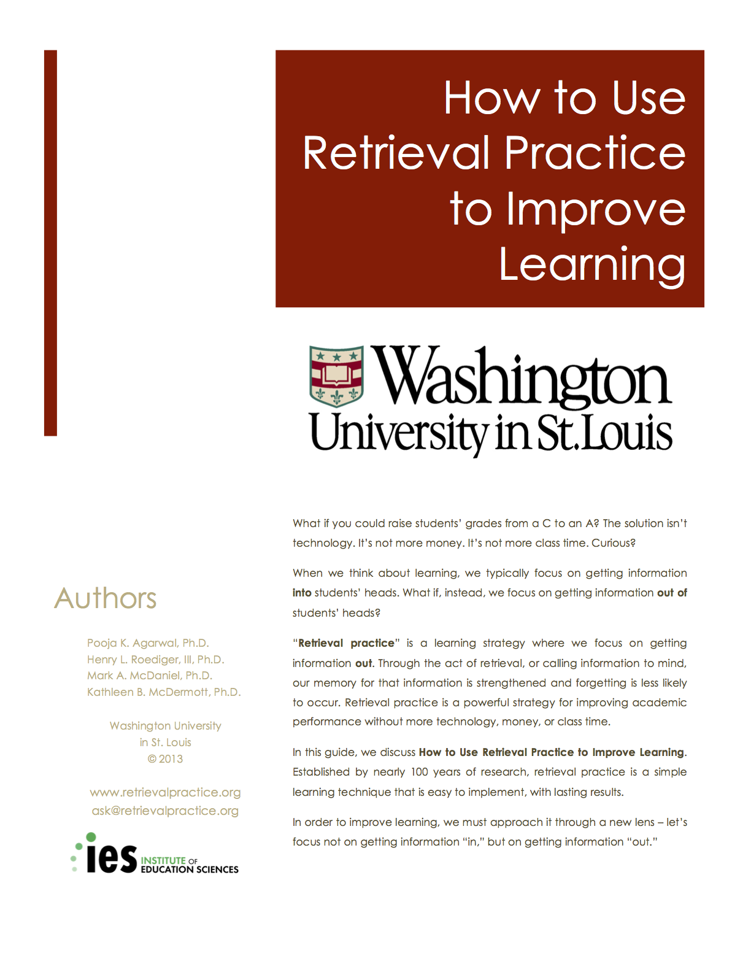

B

The Surprising Effects of Retrieving Information from Memory
“Retrieval practice,” say the authors, “makes learning effortful and challenging. Because retrieving information requires mental effort, we often think we are doing poorly if we can’t remember something. We may feel like progress is slow, but that’s when our best learning takes place. The more difficult the retrieval practice, the better it is for long-term learning… Slower, effortful retrieval leads to long-term learning. In contrast, easy strategies only lead to short-term learning.”

Adapted from How to Use Retrieval Practice to Improve Learning. Pooja Agarwal, Henry Roediger, Mark McDaniel, and Kathleen McDermott (Washington University/St. Louis). 2013

C

The Surprising Effects of Retrieving Information from Memory
What’s more, retrieval increases understanding and higher-order functions. It improves students’:
- Complex thinking and application skills;
- Organization of knowledge;
- Transfer of knowledge to new concepts.
In other words, retrieval practice doesn’t just lead to memorization – it increases understanding. Through varied retrieval students adapt their set of knowledge to new situations, novel questions, and related contexts.

Adapted from How to Use Retrieval Practice to Improve Learning. Pooja Agarwal, Henry Roediger, Mark McDaniel, and Kathleen McDermott (Washington University/St. Louis). 2013

D

The Surprising Effects of Retrieving Information from Memory

The process of retrieval also clarifies for students what they don’t know. Their improved metacognitive sense of what they’ve mastered and what they haven’t gives students a more realistic sense of their status and leads to better decisions on how to focus their study.
Furthermore retrieval supports formative assessment. By seeing what students know and don’t know, teachers can adjust lesson plans to ensure that all students are on the same page (similar to formative assessment).

Adapted from How to Use Retrieval Practice to Improve Learning. Pooja Agarwal, Henry Roediger, Mark McDaniel, and Kathleen McDermott (Washington University/St. Louis). 2013

