Class:___ELL A______________ Teacher: _____Lori Segall__________________

Lesson______ The Family Tree____________________________ Date:_______Nov. 3, 2014_____________________

Skill Objective #1 (Students will be able to…)
Use family words to write 4 sentences about their family.

Frameworks: S2.2b, S23.2d, W1.2 a, W2.2a, W2.2b, W2.2 d

Content Objective #1 (Students will know that…)
Learn family vocabulary.

Frameworks:

Activities
1a. Tape to the board my family tree. Point to Lori on tree and then ask for the family words associated with the other people.

b. Students use the possessive s to respond to question, “Who’s this?” (Lori’s husband, etc)

c. Look at family vocab on Future English page 67. Draw 2 columns male and female. Start with one word and ask them for the matching one. Introduce the words parents and grandparents. Like children, they can be male and female.

d. Students work in pairs with the picture on page 67 where one asks Who’s this? and the other says “It’s Susan’s___________.”
Then have them make sentences looking at the family tree on page 66, e.g. , “David is Susan’s husband.”

e. Ask a student, “Is someone in your family here with you in the US?” What’s his or her name?
Model writing a sentence: My husband’s name is Miguel. My mother lives in Somerville, etc. Students write 4 sentences about people in their family for homework.

Materials
Lori’s family tree with associated 8x 10 inch labeled family photo

Assessment #1
Homework assignment turned in

Wrap Up Reflection

Skill Objective #2 (Students will be able to…)
Use the correct possessive adjectives in a fill-in blank exercise about the Obama family

Frameworks: S2.2c, W2.2d

Content Objective #2 (Students will know that…)

Possessive adjectives go with the primary person, not the object
Frameworks:

Activities
1a. Write on the board
I – my
You – your
He – his
She – her

Point – my book, your book, his book, her book. His/her depends on the person, not the object.
Point to yourself – My name is Liz. Point to a woman in the class - Her name is _____. Point to a man – His name is _______.

Put up my family tree again. Point to male relatives and say ‘her father, her brother.’ His her goes with the primary person.

b. Do ‘my-your-his-her’ handout in class. Ask students to check their answers with their partners. Who is correct? They talk and decide. Correct as a group.

c. Add to the board list:
We – our
They – their explain differences between their, there and they’re in usage

d. Look at 4 pictures on page 70 of Future English 1, do practice Ex. A.

e. Students complete Obama family handout with correct possessive adjective.

Materials
My-your-his-her handout, Obama family handout

Assessment #2
Completed Obama family handout

Wrap Up Reflection
In MA, women can marry women and we use the word wife and a man can marry a man and we use the word husband. If we talk about the husband of a specific man, what is the possessive adjective we use?

The Obama Family
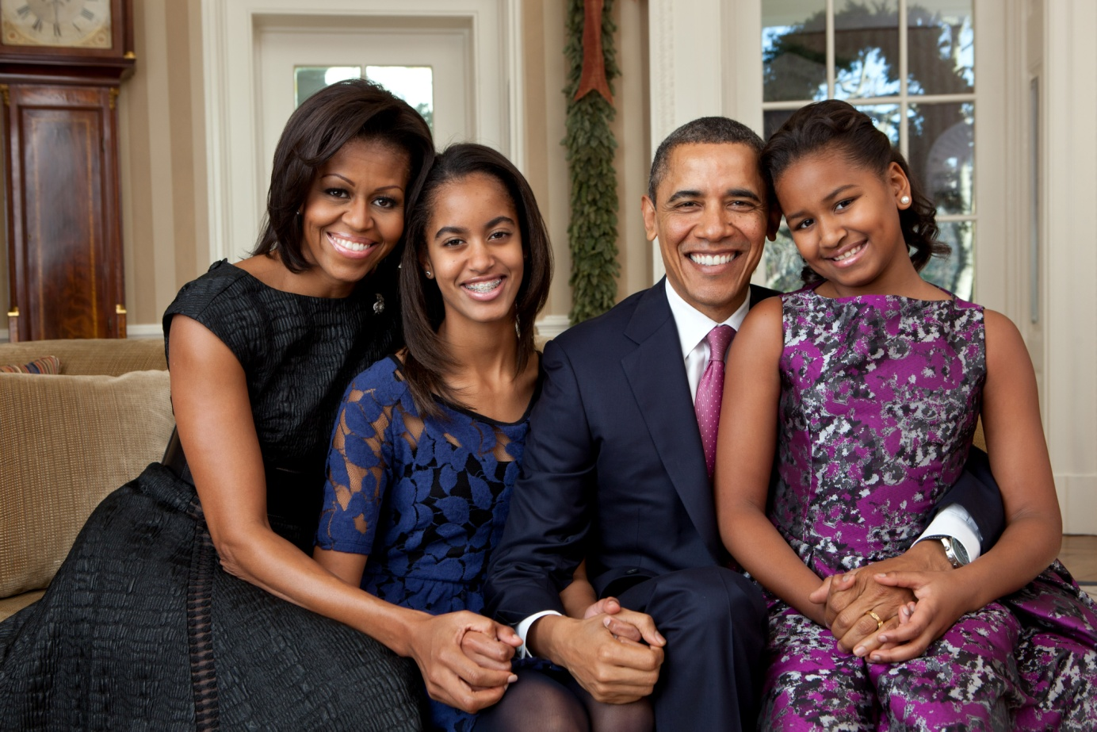

Put the correct possessive adjective on each line: his her their

This is President Obama’s family. _______ wife is Michelle. ________ daughters are Malia and Natasha. Natasha is the one wearing the dress with purple flowers. Do you like _______ dress? She is sitting on ________ father’s lap. They live in Washington DC. __________house is the White House! They have a dog named Bo. They love _________ dog!
Grammar
Write the correct word in the box on the line

my your his her

- Fernanda comes to class with _______ books and binder.

- Johnson has _______ binder today, too.

- Silvia lives in Everett with ______ daughter.

- I live in Somerville with ______ husband.

- You can write in ______ workbook.

- Mercedes lives in Somerville but _____ family lives in Mexico.

- Please don’t talk on ______ cell phone in class.

- Santos uses a purse like that. I think it’s ________ purse.

- Edwin is not in class today. I sit at ______desk.

- I sit here every day. It is _____ chair!

