The Obama Family

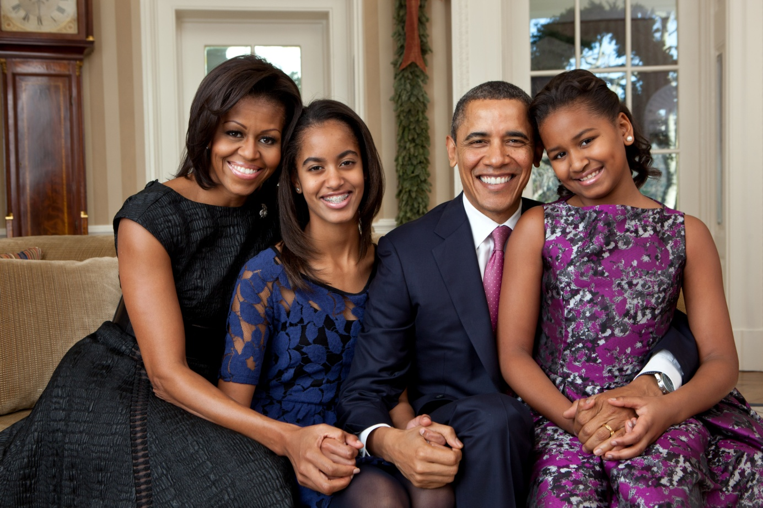

Put the correct possessive adjective on each line: his her their

This is President Obama’s family. _______ wife is Michelle. ________ daughters are Malia and Natasha. Natasha is the one wearing the dress with purple flowers. Do you like _______ dress? She is sitting on ________ father’s lap. They live in Washington DC. __________house is the White House! They have a dog named Bo. They love _________ dog!

