**Stretches you can try at home! Try not to bounce.**

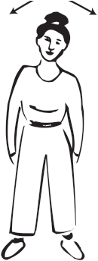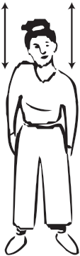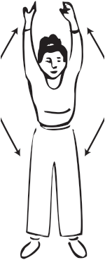

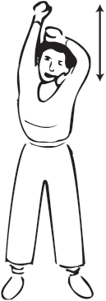

**Deep breathing**

Arms up, breath in, arms down, breath out. Two times each.

**Neck Stretching**

Side to side. Two times.

**Shoulder Stretches**

Up and down 5 times on each side.

**Side Stretches**

Up and down 5 times in each direction.

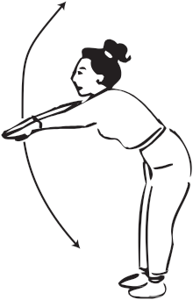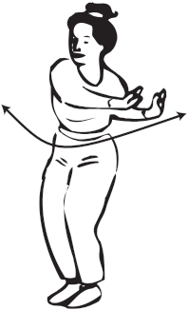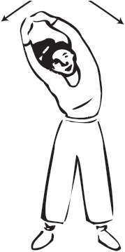

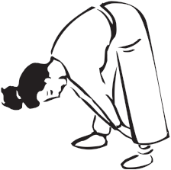

**Twists**

Side to side 3 times in each direction.

**Back & Leg Stretches**

Down and up 5 times.

**Waist Stretches**

Side to side 3 times in each direction.

**Back Stretch**

Arms through legs 6 times.

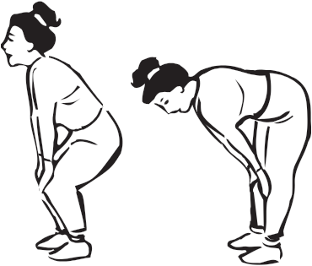

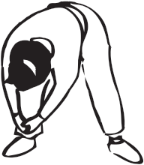

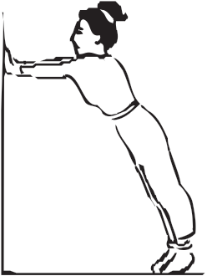

*Developed by the California Diabetes Control Program, Department of Health Services, and State of California.*

**Leg Stretches (3)**

Move heels down and up 6 times.

**Leg Stretches (2)**

Down and up 5 times.

**Leg Stretches**

Hold on to ankles. 4 times on each side.

