Create eight (8) sentences using the affirmative or negative of the present continuous based on the following picture:

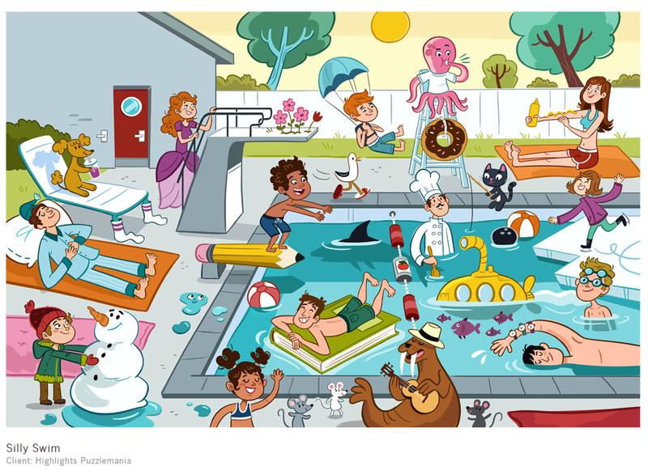

Swim
Make
Dive
Skate
Put
Float
Play
Wave
Drink
Relax

