Class: ELL Level 3 Teacher: J. LaVecchio
Lesson: “Somebody that I used to know” Date:
Skill Objective #1 (Students will be able to…)  Correctly use the form “used to” to talk about past events that they no longer do or habitual actions in the past. | Skill Objective #2 (Students will be able to…)  Synthesize “used to” form by creating sentences about a scene.
Frameworks: L1.4c, L2.3a, L3.4, S2.4b, S3.3d | Frameworks: : L1.2d, L3.3a, S2.3, R1.4a, R3.4b, W1.4d, W3.4b
Content Objective #1 (Students will know that…)  The form “used to” is another facet to talking about past events, especially habitual actions in the past. (They’ve already been reviewing Simple Past and Past Continuous) | Content Objective #2 (Students will know that…)  - “used to” form is commonly used for past events that no longer occur or habitual action.  - browsers can be easily split on screen in order to do multiple things on a computer.
Activities  1a.  Warm up – Ask students to create sentences using simple past about what they did as they were growing up.  - Model five sentences on the board. Review subject and verbs in sentences.  b. Begin talking about form “used + infinitive form of the verb” and how it relates to past actions that no longer occur or habitual actions  c. Also, review with students negative and question forms using “used to” and how the form changes to “use to” in the negative and questions.  Subjects also do not affect the verb “used”  d. Take two sentences from the board and model the “used to” change. Have students complete the other three in pairs.  e. Students work on handout on “used to” form (attached) | Activities  1a.  Warm up – In computer lab, project image of a modern day beach scene (attached). Orally review what students see in picture.  b. Present other image from a past beach scene (attached). Have students access image on web browser for a closer look.  c. Secondly, have students open Microsoft Word and teach students how to split the desktop with two windows so the image is on one side and the Microsoft office on the other side of the screen.  d. Students will type eight sentences using “used to”  e. Students will also have the opportunity to have free time on the computer to use “focus on grammar” or “pronunciation power”
Materials  Handout on “used to” | Materials  Two pictures of beach images. One present day and the other an artist rendition of a past beach scene.  Computers (Microsoft Word)
Assessment #1  - Pair work changing simple past tense verbs to “used to”  - Handout on “used to” (attached)  - Continuous assessment of pronunciation and use. | Assessment #2  - Computer work creating sentences using “used to”  - Students are able to successfully split windows on computer.
Wrap Up Reflection | Wrap Up Reflection

Modern Beach Picture
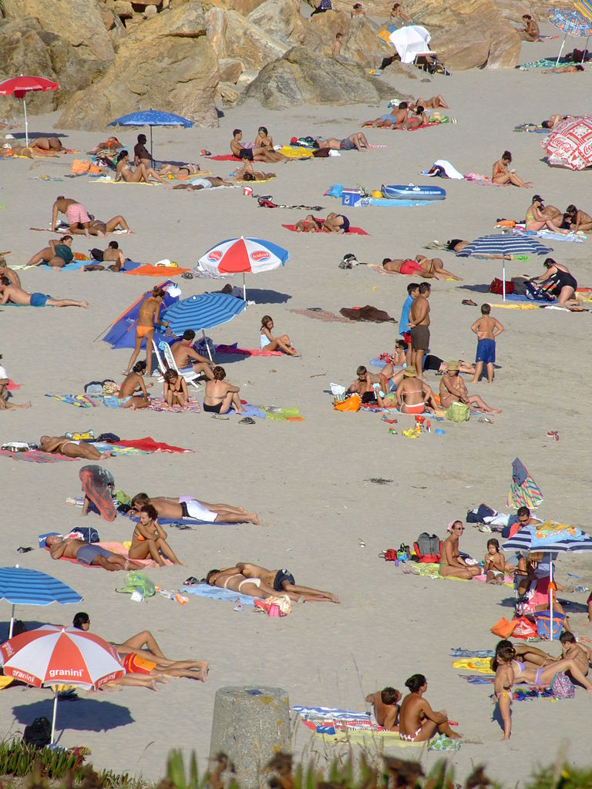

Past beach picture
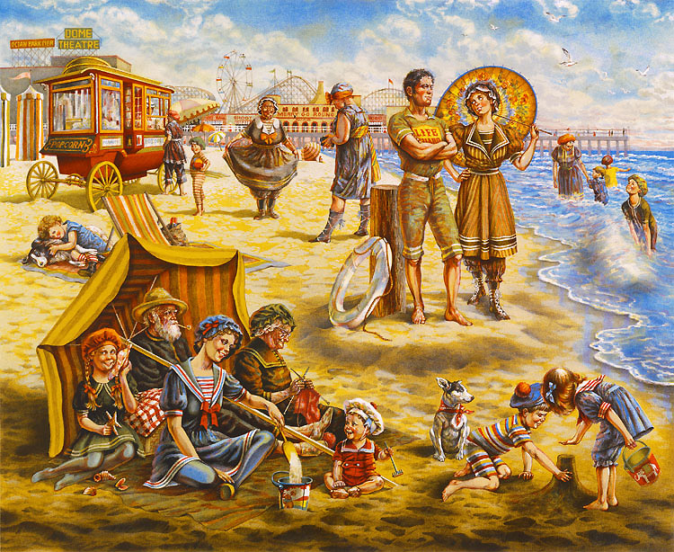

“Used to” Handout with sentence creation activity
