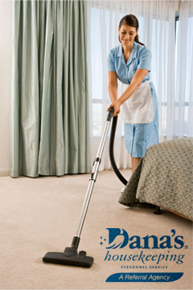  1. a housekeeper  A housekeeper cleans hotel rooms. | 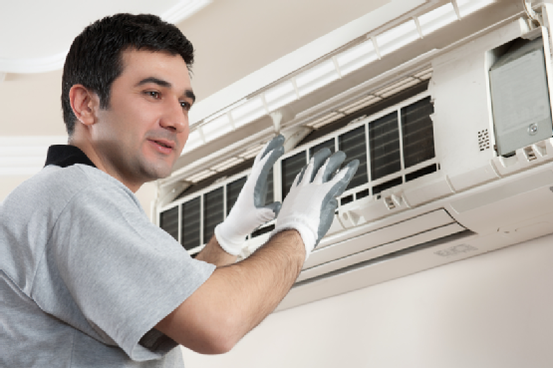  2. an HVAC technician  An HVAC technician fixes air-conditioners and heaters.
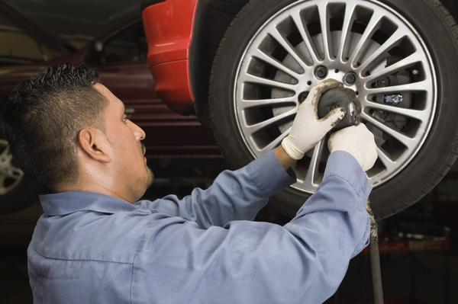  3. an auto mechanic  An auto mechanic fixes cars and trucks. | 4. a CNA (certified nursing assistant)  A CNA helps patients shower, get dressed and eat.

OCCUPATIONS – page 1

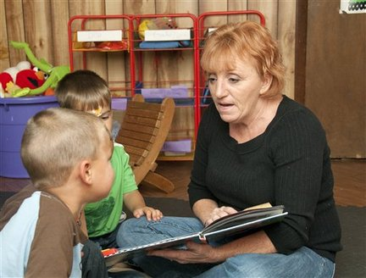  5. a child care worker  A child care worker helps take care of children when their parents are busy. | 6. a bank teller  A bank teller helps bank customers cash checks and put in or take out money.
7. a clinical laboratory technologist  A clinical laboratory technologist takes blood for health tests. | 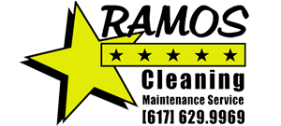  8. a self-employed person  A self-employed person has a business and is responsible for it.

OCCUPATIONS– page 2

